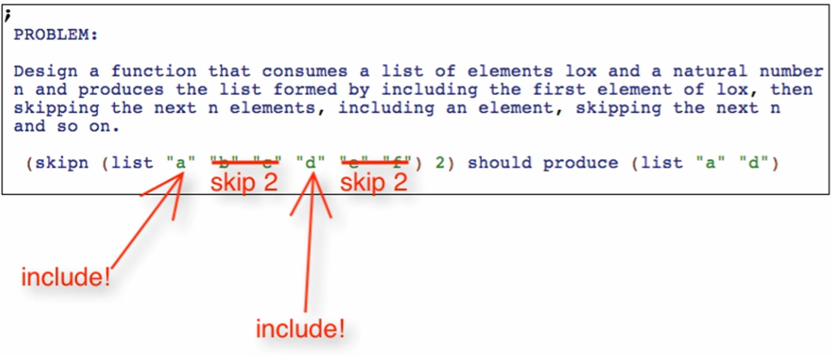

* Need to track how many more elements to skip

**Signature, purpose, stub**

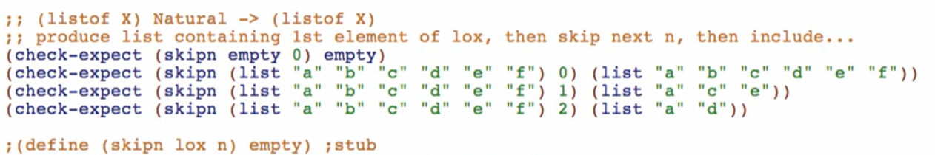

* Test case for n=0 means that we can skip 0 elements and return the original list

**Template**

1. Structural recursion template

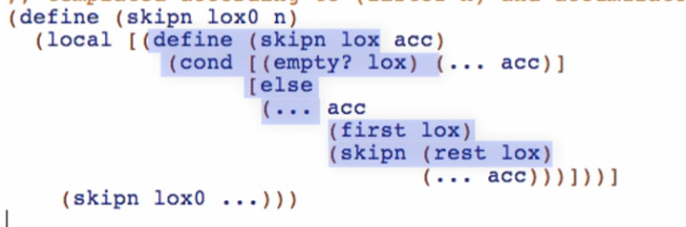

1. Wrapping in outer function, local, and trampoline

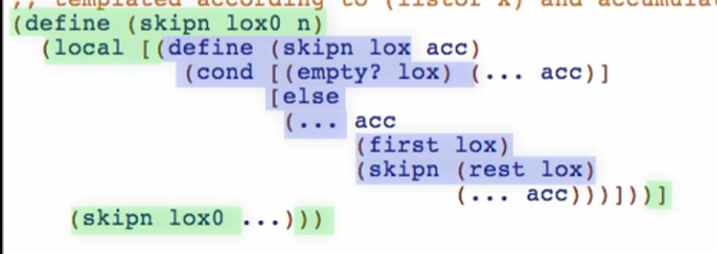

1. Adding the additional accumulator parameter

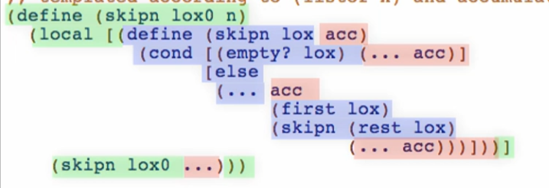

Type, Invariant and Examples of the accumulator

*Examples:*

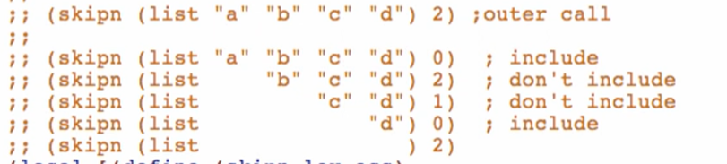

* We can use these examples as basis for the type and invariant

*Type:*



*Invariant:*



**Code body**

Base case

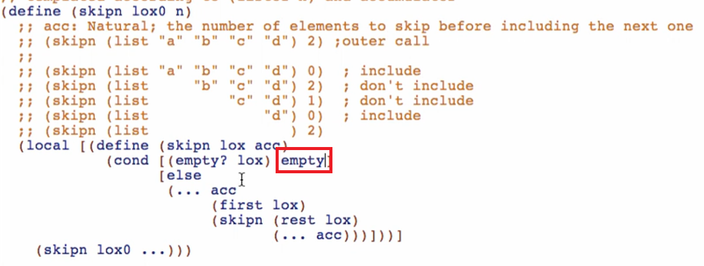

Other cases

1st step: exploit/use the accumulator

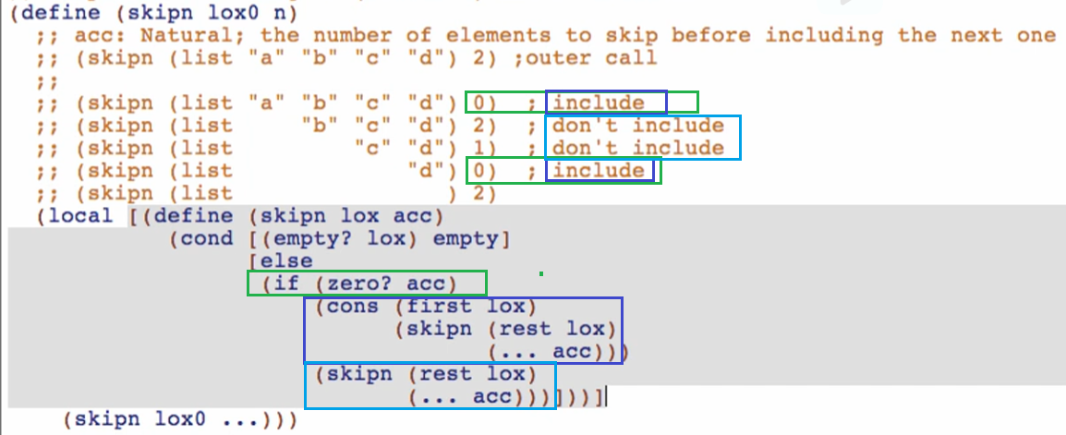

2nd step: initialize the accumulator

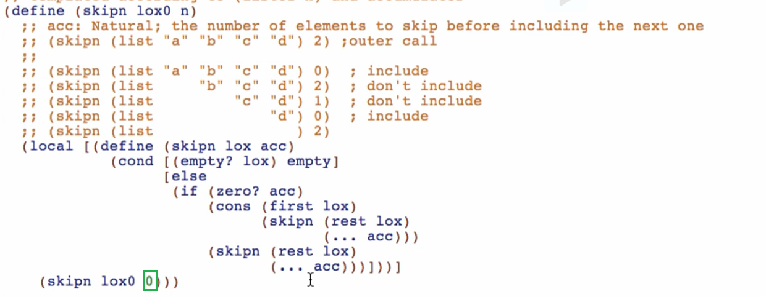

3rd step: update the accumulator in each recursive call

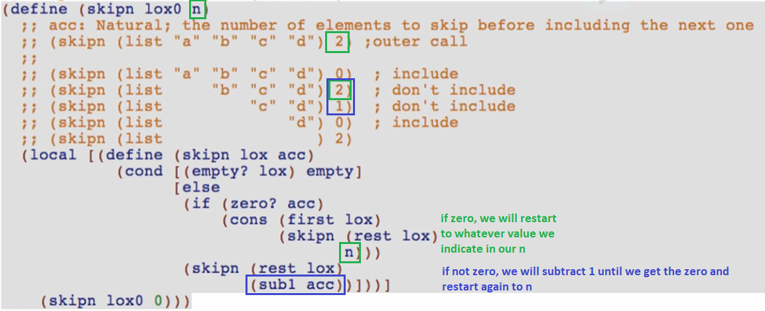

Run and debug!

Try using “count-up” for this problem in your version